How to use the address parser

Needed:
- oop_address-search_multiple-instance_table.php = a PHP file to run for address parsing.
PATH: C:\xampp\htdocs\AddressParser
- database = a local database that has been set-up locally. Note: the database should have an 'address' field.

- Open the PHP file and set-up the SQL query.

- Then Run the PHP file in the Browser
Example:
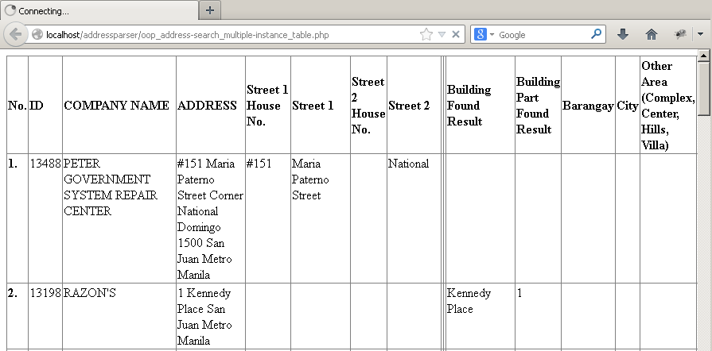

- Wait until its finished then copy the html table in Excel.

